**COMPARATIVE STUDY OF EFFECT OF**

**POTASSIUM BISULPHITE AND SODIUM BENZOATE AS FOOD PRESERVATIVES UNDER VARIOUS CONDITIONS**.

##### COLLEGE WITH POTENTIAL FOR EXCELLENCE

UNDER UGC SCHEME 2019

(UNDER GRADUATE LEVEL)

PATNA WOMEN’S COLLEGE

AUTONOMOUS

NAAC Re-Accredited-‘A’ Grade with CGPA 3.58/4

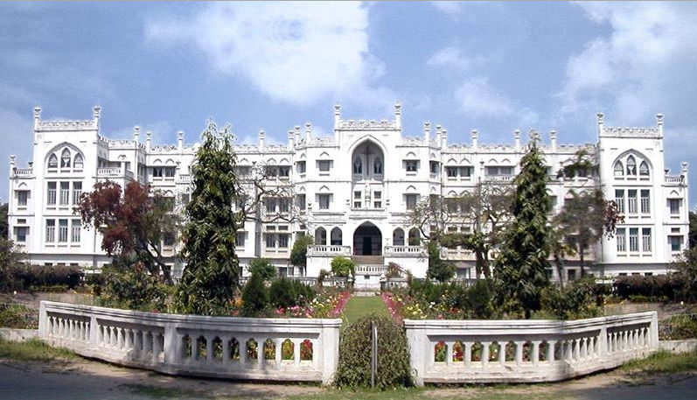

RESEARCH CONDUCTED BY:

Anita Sah, Roll No: 65

Surbhi Barman, Roll No: 67

Akankha Kundu, Roll No. 216

**CONTENTS**

Page no.

* ACKNOWLEDGEMENT 3
* CERTIFICATE 4
* INTRODUCTION 5-6
* METHODOLOGY 7-9
* OBSERVATION 9-35
* RESULT AND DISCUSSION 36-37
* CONCLUSION 38
* REFERENCES 39

**ACKNOWLEDGEMENT**

###### We would like to express our thanks of gratitude to our respected principal Dr. Sister M Rashmi for giving us this golden opportunity to do this research project and for providing us with all the facilities that was required. We would also like to extend our gratitude to Dr. Madhurani Sinha and Ms. Amita Prasad for their guidance and support in completing our project.

###### Their suggestions and instructions have served as the major contributor towards the completion of the project. Last but not the least we would like to thanks all the people who have been concerned with this project.

**CERTIFICATE**

*This is to certify that Anita Sah(65), Surbhi Barman(67) and Akankha Kundu(216) of B.Sc. 3rd year, chemistry honors, Patna Women’s College has successfully completed their research project on the topic “ COMPARATIVE STUDY OF EFFECT OF POTASSIUM BISULPHITE AND SODIUM BENZOATE AS FOOD PRESERVATIVE UNDER VARIOUS CONDITONS” under the guidance of Ms. Amita Prasad.*

*HEAD OF THE DEPARTMENT:*

*Dr. Madhurani Sinha*

**INTRODUCTION**

A preservative is a substance which is added to product such as food, beverages, pharmaceutical drugs, cosmetics and many other products to prevent decomposition from the growth of micro organism or by undesirable chemical changes.

Spoilage of food is natural process which is caused due to temperature, time and many other enzymatic reactions.

Other than preventing food from spoilage, preservative also enhance the flavor and texture of food.

Use of preservative started in prehistoric times .In ancient times the preservation of foods were done by the process of drying, fermenting, adding vinegar, alcohol etc. For example – Smoked meat has phenols that delayed the spoilage .With the evolution of time new technique has been introduced such as pasteurization, irradiation, vacuum packing etc.

**Preservative are of two types:** Natural preservative and chemical preservative. Salts, sugar, alcohol, vinegar comes in the category of natural preservative while benzoates, nitrites, sulphites, etc comes in the category of chemical preservative. Basically preservatives works by releasing some chemicals which retard or prevent the growth of microbial organisms or by maintaining the pH level of food which does not favors the growth of bacteria or fungus.

**In this research work we mainly focus on two chemical preservatives:**

1. **Sodium benzoate (C6H5COONa)**
2. **Potassium bisulphate (KHSO3)**

Sodium benzoate or sodium salt of benzoic acid is a common type of preservative used in acidic foods, drinks, jam etc.

It works by balancing the pH level of food. It is also used as flavor enhancer. Sodium benzoate has also very harmful effect that it has ability to convert into benzene, a known carcinogen .It increases the risk of inflammation, oxidation stress, obesity ,ADHD(Attention deficit hyperactivity disorder) and allergies .So its use is limited by FDA in the U.S to 0.1% by weight.

“Potassium bisulphite is used in the preservation of colorless food items such as fruit juices of coconut, lemon etc as sulphur dioxide produced from this chemical has a bleaching agent which may change the color of food”. When it reacts with acids present in juice it liberates SO2 gas which kills the harmful germs and prevents from getting spoiled .It is a popular preservative because it is effective and does not change the qualities such as taste, smell or appearance. It is generally regarded as safe as it does not accumulate in our body.

**METHODOLOGY:-**

**PREPARATION OF JAM AND JUICES:**

**.** First fresh fruits were taken, washed with normal water and their outer skin was peeled off.

**.**Then it was cut into small pieces and grinded in mortar pestle to make a fine paste.

**.**Now the paste was heated and sugar and food coloring was added to make a jam of desirable consistency.

**.**The material so obtained is fruit jam which is then used to study the effect of concentration of sugar, concentration of two different preservative (sodium benzoate and potassium bisulphite), effect of temperature and effect of time.

1. **EFFECT OF CONCENTRATION OF SUGAR ON MANGO JAM/MOUSAMBI JUICE/COCONUT WATER (KHSO3/C6H5COONa):-**
2. Three beakers were taken and labeled as I, II, III.
3. 80 gm of mango jam/40 ml of mousambi juice/40 ml coconut water was put in each beaker.
4. 5 gm, 10 gm, 15 gm of sugar was added in beaker no. I II, III respectively.
5. 0.5 gm of KHSO3 /C6H5COONa was added in each beaker.
6. The contents were mixed thoroughly with stirring rod.
7. The bottle was closed and was allowed to stand for some days at room temperature to observe the changes taking place in jam every day.
8. **EFFECT OF CONCENTRATION OF KHSO3 ON MANGO JAM/MOUSAMBI JUICE/COCONUT WATER (KHSO3/C6H5COONa):-**
9. Three beakers were taken and labeled as I, II, III.
10. 80 gm of jam/40 ml of mousambi juice/40 ml coconut water was put in each beaker.
11. 5 gm of sugar was added in each beaker.
12. 1 gm, 2 gm and 3 gm of KHSO3/C6H5COONa was added in beaker I, II and III respectively.
13. The contents were mixed thoroughly with a glass rod.
14. All the beakers were kept at room temperature for some days and changes were observed.

**(C)EFFECT OF DIFFERENT TEMPERATURE ON MANGO JAM/MOUSAMBI JUICE/COCONUT WATER (KHSO3/C6H5COONa):-**

1. Three beakers were taken and labeled as I, II, III.
2. 80 gm of jam/40 ml of mousambi juice/40 ml coconut water was taken in each beaker.
3. 10 gm of sugar and 1 gm of KHSO3/C6H5COONa was added in beaker I and II respectively.
4. Contents were mixed with stirring rod.
5. Beaker I was kept for some days at 0 degree Celsius and beaker II was kept at room temperature 25 degree Celsius.
6. Changes were observed every day.

**(D)EFFECT OF TIME ON MANGO JAM /MOUSAMBI JUICE/COCONUT WATER (KHSO3/C6H5COONa):-**

1. Three beakers were taken and labeled as I, II, III.
2. 80 gm of mango jam /40 ml of mousambi juice/40 ml coconut water was added in each beaker and 1 gm of KHSO3/C6H5COONa was added in each beaker respectively.
3. Contents were mixed with stirring rod.
4. Beaker I was allowed to stand for 7 days, beaker II was allowed to stand for 14 days and beaker III was allowed to stand for 21 days.
5. Changes taking place was observed every day.

**OBSERVATION:-**

|  |  |  |  |  |  |  |  |  |  |  |
| --- | --- | --- | --- | --- | --- | --- | --- | --- | --- | --- |
| **EFFECT OF SUGAR ON MANGO JAM (KHSO3)** | | | | | | | | | | |
| **Bottle no.** | **Wt. of sugar** | **Wt. of KHSO3** |  | **1** | **2** | **3** | **4** | **5** | **6** | **7** |
| **I** | **5 gm** | **0.5 gm** | **color** | No | No | No | No | no | Orange | Light orange |
| **I** | **5 gm** | **0.5 gm** | **odour** | No | No | No | Pungent smell | Pungent smell | Ethanolic smell | Strong ethanolic smell |
| **I** | **5 gm** | **0.5 gm** | **fungus** | No | No | No | Few white fungus | More white fungus | White and greenish fungus | Greenish fungus |
| **II** | **10 gm** | **0.5 gm** | **color** | No | No | No | Orange | orange | Light orange | Light orange |
| **II** | **10 gm** | **0.5 gm** | **odour** | No | No | Pungent smell | Pungent smell | Strong pungent smell | Ethanolic smell | Ethanolic smell |
| **II** | **10 gm** | **0.5 gm** | **fungus** | No | No | Few white fungus | White fungus | Greenish fungus | Greenish fungus | Black fungus |
| **III** | **15 gm** | **0.5 gm** | **color** | No | No | No | orange | orange | orange | Light orange |
| **III** | **15 gm** | **0.5 gm** | **odour** | No | No | Pungent smell | Pungent smell | Ethanolic smell | Ethanolic smell | Ethanolic smell |
| **III** | **15 gm** | **0.5 gm** | **fungus** | No | No | White fungus | More white fungus | Greenish fungus | More greenish fungus | Black fungus |

**OBSERVATION:-**

|  |  |  |  |  |  |  |  |  |  |  |  |  |
| --- | --- | --- | --- | --- | --- | --- | --- | --- | --- | --- | --- | --- |
| **EFFECT OF PRESERVATIVE KHSO3 ON MANGO JAM** | | | | | | | | | | | | |
| **Bottle no.** | **Wt. of sugar** | **Wt. of KHSO3** |  | **1** | **2** | **3** | **4** | **5** | **6** | **7** | **8** | **9** |
| **I** | **5gm** | **1 gm** | **Color** | no | No | no | no | no | no | No | no | no |
| **I** | **5 gm** | **1 gm** | **Odour** | … | … | Slight pungent smell | Pungent smell | Pungent smell | Strong pungent smell | Strong pungent smell | Ethanolic smell | Ethanolic smell |
| **I** | **5 gm** | **1 gm** | **Fungus** | … | … | … | Few white fungus | More white fungus | White and greenish fungus | Greenish fungus | Black fungus formed | spoilt |
| **II** | **5 gm** | **2 gm** | **Color** | … | … | … | … | … | … | … | … | … |
| **II** | **5 gm** | **2 gm** | **Odour** | … | … | … | Slight pungent smell | Pungent smell | Pungent smell | Pungent smell | Strong pungent smell | Ethanolic smell |
| **II** | **5 gm** | **2 gm** | **Fungus** | … | … | … | … | Few white fungus | White fungus | More white fungus | Greenish fungus | More greenish fungus |
| **III** | **5 gm** | **3 gm** | **color** | … | … | … | … | … | … | … | … | … |
| **III** | **5 gm** | **3 gm** | **Odour** | … | … | … | … | … | … | Slight pungent smell | Pungent smell | Pungent smell |
| **III** | **5 gm** | **3 gm** | **fungus** | … | … | … | … | … | Few White fungus | More white fungus | White fungus | Greenish fungus |

|  |  |  |  |
| --- | --- | --- | --- |
| **EFFECT OF TEMPERATURE ON MANGO JAM** | | | |
| **Bottle no.** |  | **I** | **II** |
| **Temperature** |  | **0 degree** | **25 degree** |
| **Wt. of sugar** |  | **10 gm** | **10 gm** |
| **Wt. of KHSO3** |  | **1 gm** | **1 gm** |
| **Day 1** | **color** | … | … |
|  | **odour** | … | … |
|  | **fungus** | … | … |
| **Day 2** | **color** | … | … |
|  | **odour** | … | … |
|  | **fungus** | … | … |
| **Day 3** | **color** | … | … |
|  | **odour** | … | Slight unpleasant smell |
|  | **Fungus** | … | White fungus |
| **Day 4** | **Color** | … | … |
|  | **Odour** | … | Unpleasant smell |
|  | **Fungus** | … | White fungus |
| **Day 5** | **Color** | … | … |
|  | **Odour** | … | Pungent smell |
|  | **Fungus** | … | Greenish fungus |
| **Day 6** | **Color** | … | … |
|  | **Odour** | … | Pungent smell |
|  | **Fungus** | … | Greenish fungus |
| **Day 7** | **Color** | … | Dark orange |
|  | **Odour** | … | Strong pungent smell |
|  | **Fungus** | .. | Greenish and black fungus |

**OBSERVATION:-**

**OBSERVATION:-**

|  |  |  |  |  |
| --- | --- | --- | --- | --- |
| **EFFECT OF TIME ON MANGO JAM** | | | | |
| **Bottle no.** |  | **I** | **II** | **III** |
| **Wt. of KHSO3** |  | 1 **gm** | **1 gm** | **1 gm** |
| **Days** |  | 7 days | 14 days | 21 days |
|  | Color | … | … | Dark orange |
|  | Odour | Slight unpleasant smell | Unpleasant smell | Unpleasant smell |
|  | Fungus | … | Few white fungus | White and black fungus |

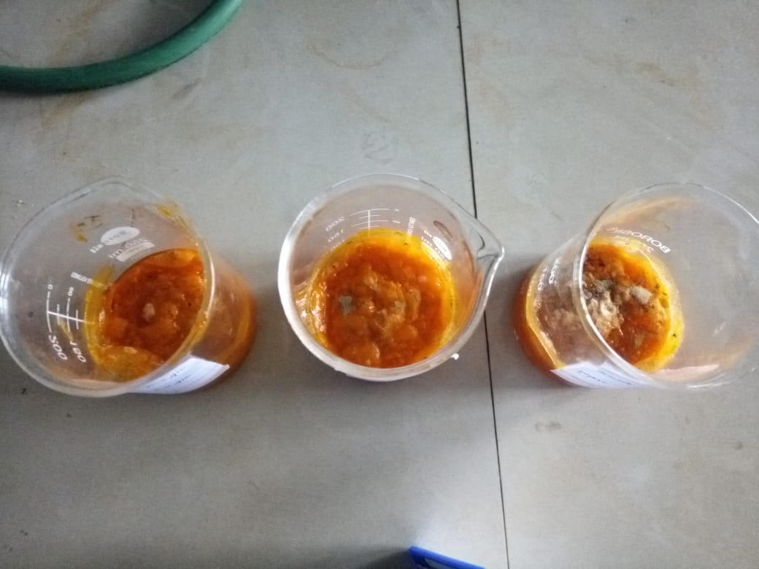

**Fig 1: shows rate of fermentation in 7 days, 14 days, 21 days of KHSO3 preservative in mango jam**

**OBSERVATION :-**

|  |  |  |  |  |  |  |  |  |  |
| --- | --- | --- | --- | --- | --- | --- | --- | --- | --- |
| **EFFECT OF SUGAR ON MANGO JAM (C6H5COONa)** | | | | | | | | | |
| **Bottle no.** | **Wt. of sugar** | **Wt. of C6H5COONa** |  | **Day 1 to 4** | **5** | **6** | **7** | **8** | **9** |
| **I** | **5 gm** | **0.5 gm** | **Color** | orange | orange | Orange | orange | Dark orange | Dark orange |
| **I** | **5 gm** | **0.5 gm** | **Odour** | Pleasant smell | Pleasant smell | Slight pungent smell | Slight pungent smell | Pungent smell | Pungent smell |
| **I** | **5 gm** | **0.5 gm** | **Fungus** | No | No | no | no | No | Few fungus |
| **II** | **10 gm** | **0.5 gm** | **Color** | Orange | orange | orange | orange | Dark orange | Dark orange |
| **II** | **10 gm** | **0.5 gm** | **Odour** | Pleasant smell | Slight pungent smell | Slight pungent smell | Pungent smell | Pungent smell | Ethanolic smell |
| **II** | **10 gm** | **0.5 gm** | **Fungus** | No | No | no | no | Few white fungus | Few fungus |
| **III** | **15 gm** | **0.5 gm** | **color** | Dark orange | Dark orange | Dark orange | Dark orange | Dark orange | Brownish orange |
| **III** | **15 gm** | **0.5 gm** | **Odour** | Pleasant smell | Pungent smell | Strong pungent smell | ethanolic smell | Ethanolic smell | Strong ethanolic smell |
| **III** | **15 gm** | **0.5 gm** | **fungus** | no | no | no | White fungus | White fungus | White and black fungus |

**OBSERVATION :-**

|  |  |  |  |  |  |  |  |  |  |  |  |  |
| --- | --- | --- | --- | --- | --- | --- | --- | --- | --- | --- | --- | --- |
| **EFFECT OF PRESERVATIVE C6H5COONa ON MANGO JAM** | | | | | | | | | | | | |
| **Bottle no.** | **Wt. of sugar** | **Wt. of C6H5C0ONa** |  | **1** | **2** | **3** | **4** | **5** | **6** | **7** | **8** | **9** |
| **I** | **5gm** | **1 gm** | **Color** | … | … | … | Dark orange | Dark orange | Dark orange | Dark orange | Dark orange | brownish |
| **I** | **5 gm** | **1 gm** | **Odor** | … | … | … | Slight Pungent smell | Slight Pungent smell | pungent smell | Strong pungent smell | Strong pungent smell | Ethanolic smell |
| **I** | **5 gm** | **1 gm** | **Fungus** | … | … | … | … | … | … | Few white fungus | More white fungus | Greenish fungus |
| **II** | **5 gm** | **2 gm** | **Color** | … | … | … | … | … | Dark orange | Dark orange | Dark orange | Dark orange |
| **II** | **5 gm** | **2 gm** | **Odor** | … | … | … | … | Slight Pungent smell | Slight Pungent smell | Pungent smell | pungent smell | Strong pungent smell |
| **II** | **5 gm** | **2 gm** | **Fungus** | … | … | … | … | … | … | … | White fungus | More white fungus |
| **III** | **5 gm** | **3 gm** | **color** | … | … | … | … | … | Dark orange | Dark orange | Dark orange | Dark orange |
| **III** | **5 gm** | **3 gm** | **Odor** | … | … | … | … | … | … | Slight pungent smell | Pungent smell | Pungent smell |
| **III** | **5 gm** | **3 gm** | **fungus** | … | … | … | … | … | … | … | … | Few white fungus |

**OBSERVATION :-**

|  |  |  |  |
| --- | --- | --- | --- |
| **EFFECT OF TEMPERATURE ON MANGO JAM** | | | |
| **Bottle no.** |  | **I** | **II** |
| **Temperature** |  | **0 degree** | **25 degree** |
| **Wt. of sugar** |  | **10 gm** | **10 gm** |
| **Wt. of C6H5COONa** |  | **1 gm** | **1 gm** |
| **Day 1 to 5** | **Color** | … | … |
|  | **Odour** | … | … |
|  | **Fungus** | … | … |
| **Day 6** | **Color** | … | … |
|  | **Odour** | … | … |
|  | **Fungus** | … | … |
| **Day 7** | **Color** | … | Dark orange |
|  | **Odour** | … | unpleasant smell |
|  | **Fungus** | … | … |
| **Day 8** | **Color** | … | Dark orange |
|  | **Odour** | … | Unpleasant smell |
|  | **Fungus** | … | … |
| **Day 9** | **Color** | … | Dark orange |
|  | **Odour** | … | Pungent smell |
|  | **Fungus** | … | … |
| **Day 10** | **Color** | Dark orange | Dark orange |
|  | **Odour** | … | Pungent smell |
|  | **Fungus** | … | … |
| **Day 11** | **Color** | Dark orange | Dark orange |
|  | **Odour** | … | pungent smell |
|  | **Fungus** | .. | … |

**OBSERVATION :-**

|  |  |  |  |  |
| --- | --- | --- | --- | --- |
| **EFFECT OF TIME ON MANGO JAM** | | | | |
| **Bottle no.** |  | **I** | **II** | **III** |
| **Wt. of C6H5COONa** |  | **1 gm** | **1 gm** | **1 gm** |
|  |  | **7 days** | **14 days** | **21 days** |
|  | **Color** | Dark orange | Dark orange | Dark orange |
|  | **Odour** | Pleasant smell | Pleasant smell | Unpleasant smell |
|  | **Fungus** | … | … | Few fungus on the wall of beaker |

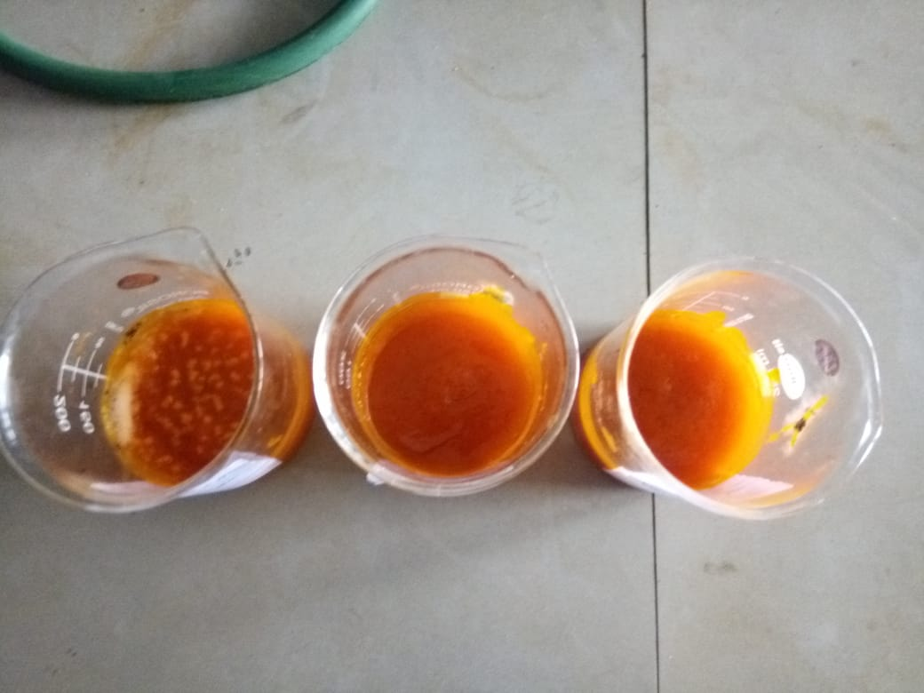 **Fig 2: shows rate of fermentation in 7 days, 14 days and 21 days of C6H5COONa preservative in mango jam**

**OBSERVATION:-**

|  |  |  |  |  |  |  |  |  |  |  |
| --- | --- | --- | --- | --- | --- | --- | --- | --- | --- | --- |
| **EFFECT OF SUGAR ON MOUSAMBI JUICE (KHSO3)** | | | | | | | | | | |
| **Bottle no.** | **Wt. of sugar** | **Wt. of KHSO3** |  | **1** | **2** | **3** | **4** | **5** | **6** | **7** |
| **I** | **5 gm** | **0.5 gm** | **color** | red | Light orange | Light orange | Light orange | Light orange | Light Orange | Dark black |
| **I** | **5 gm** | **0.5 gm** | **odour** | Fruity smell | Pleasant smell | Pleasant smell | Pleasant smell | Pungent smell | Unpleasant smell | Unpleasant smell |
| **I** | **5 gm** | **0.5 gm** | **fungus** | No | No | Few fungus | Few fungus | white fungus | fungus | fungus |
| **II** | **10 gm** | **0.5 gm** | **color** | red | Light pink | Light orange | Light Orange | orange | orange | orange |
| **II** | **10 gm** | **0.5 gm** | **odour** | Fruity smell | Pleasant smell | unpleasant smell | Pungent smell | pungent smell | Unpleasant smell | Unpleasant smell |
| **II** | **10 gm** | **0.5 gm** | **fungus** | No | No | Few white fungus | White fungus | White fungus | fungus | fungus |
| **III** | **15 gm** | **0.5 gm** | **color** | red | pink | Light orange | Light orange | orange | Dark orange | Dark orange |
| **III** | **15 gm** | **0.5 gm** | **odour** | fruity | unpleasant | Pungent smell | Pungent smell | Unpleasant smell | Unpleasant smell | Unpleasant smell |
| **III** | **15 gm** | **0.5 gm** | **fungus** | No | No | White fungus | More white fungus | white fungus | fungus | fungus |

**OBSERVATION :-**

|  |  |  |  |  |  |  |  |  |  |  |
| --- | --- | --- | --- | --- | --- | --- | --- | --- | --- | --- |
| **EFFECT OF PRESERVATIVE KHSO3 ON MOUSAMBI JUICE** | | | | | | | | | | |
| **Bottle no.** | **Wt. of sugar** | **Wt. of KHSO3** |  | **Day 1** | **Day 2** | **Day 3** | **Day 4** | **Day 5** | **Day 6** | **Day 7** |
| **I** | **5 gm** | **1 gm** | **Color** | Red | red | Light pink | Light pink | Light pink | Light pink | Light orange |
| **I** | **5 gm** | **1 gm** | **Odour** | Fruity smell | Fruity smell | Fruity smell | Unpleasant smell | Unpleasant smell | Unpleasant smell | unpleasant |
| **I** | **5 gm** | **1 gm** | **Fungus** | … | … | … | … | … | … | Fungus |
| **II** | **5 gm** | **2 gm** | **Color** | Red | red | Light pink | Light pink | Light pink | Light pink | Orange |
| **II** | **5 gm** | **2 gm** | **Odour** | … | Fruity smell | Fruity smell | unpleasant | unpleasant | Unpleasant smell | unpleasant |
| **II** | **5 gm** | **2 gm** | **Fungus** | No | no | no | no | No | no | No |
| **III** | **5 gm** | **3 gm** | **colour** | Red | red | Light pink | Light pink | Dark pink | Dark pink | Dark orange |
| **III** | **5 gm** | **3 gm** | **Odour** | Fruity smell | Fruity smell | Fruity smell | Fruity smell | Unpleasant smell | Unpleasant smell | Unpleasant smell |
| **III** | **5 gm** | **3 gm** | **fungus** | No | no | no | no | no | no | No |

**OBSERVATION :-**

|  |  |  |  |
| --- | --- | --- | --- |
| **EFFECT OF TEMPERATURE ON MOUSAMBI JUICE** | | | |
| **Bottle no.** |  | **I** | **II** |
| **Temperature** |  | **0 degree** | **25 degree** |
| **Wt. of sugar** |  | **10 gm** | **10 gm** |
| **Wt. of KHSO3** |  | **1 gm** | **1 gm** |
| **Day 1** | **Color** | Light pink | Light pink |
|  | **Odour** | Fruity smell | … |
|  | **Fungus** | … | … |
| **Day 2** | **Color** | Light pink | pink |
|  | **Odour** | Fruity smell | … |
|  | **Fungus** | … | … |
| **Day 3** | **Color** | Light pink | pink |
|  | **Odour** | Fruity smell | Unpleasant smell |
|  | **Fungus** | … | … |
| **Day 4** | **Color** | Light pink | Light orange |
|  | **Odour** | … | Unpleasant smell |
|  | **Fungus** | … | … |
| **Day 5** | **Color** | Light pink | Light orange |
|  | **Odour** | … | Unpleasant smell |
|  | **Fungus** | … | … |
| **Day 6** | **Color** | Pink | Light orange |
|  | **Odour** | Unpleasant | Unpleasant smell |
|  | **Fungus** | … | Few white fungus |
| **Day 7** | **Color** | Pink | Light orange |
|  | **Odour** | Unpleasant | Unpleasant |
|  | **Fungus** | … | white fungus |
| **Day 8** | **Color** | Dark pink | Light orange |
|  | **Odour** | Unpleasant | Strong pungent smell |
|  | **Fungus** | Development of fungus started | yellow fungus |
| **Day 9** | **Color** | Dark pink | Light orange |
|  | **Odour** | Strong Unpleasant smell | Ethanolic smell |
|  | **Fungus** | white fungus | White , yellow and black fungus |
| **Day 10** | **Color** | Dark pink | Light orange |
|  | **Odour** | Strong unpleasant smell | Ethanolic smell |
|  | **Fungus** | White fungus | Black fungus |

**OBSERVATIONS :-**

|  |  |  |  |  |
| --- | --- | --- | --- | --- |
| **EFFECT OF TIME ON MOUSAMBI JUICE** | | | | |
| **Bottle no.** |  | **I** | **II** | **III** |
| **Wt. of KHSO3** |  | **1 gm** | **1 gm** | **1 gm** |
|  |  | **7 days** | **14 days** | **21 days** |
|  | **Colour** | Orange | Brown | brown |
|  | **Odour** | unpleasant smell | Unpleasant smell | Unpleasant smell |
|  | **Fungus** | … | Few white fungus | White fungus |

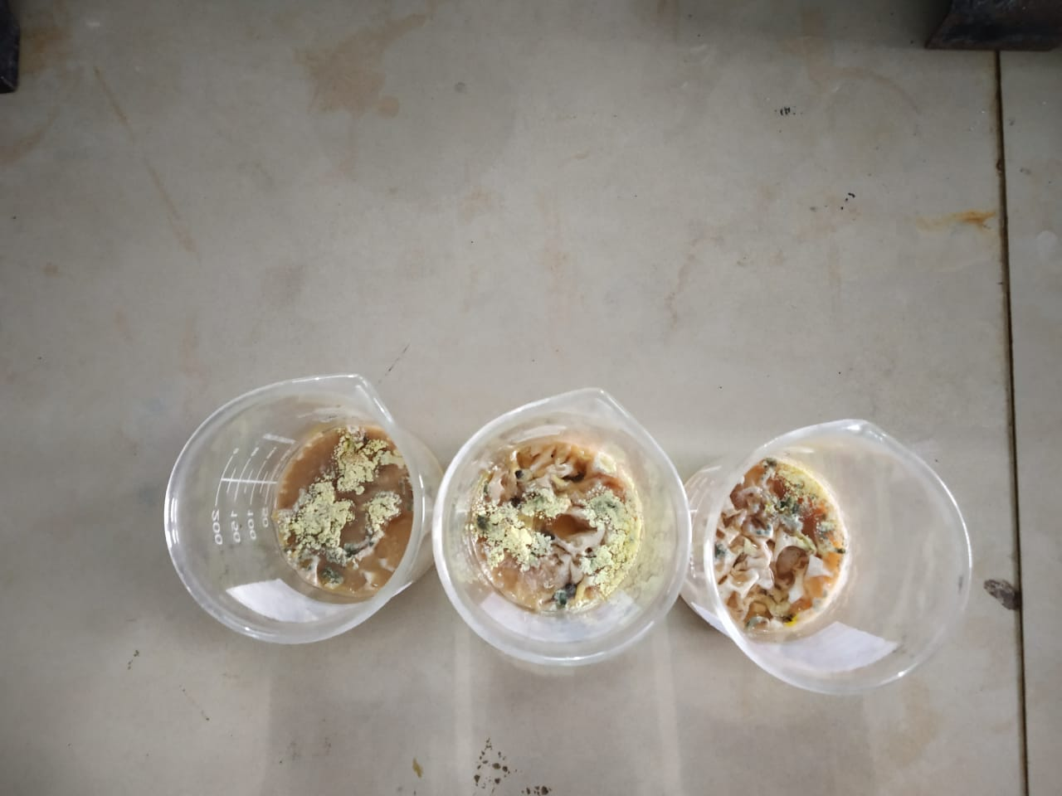 **fig3: shows rate of fermentation of 7 days, 14 days and 21 days ofKHSO3 preservative in mousambi juice**

**OBSERVATION :-**

|  |  |  |  |  |  |  |  |  |  |  |
| --- | --- | --- | --- | --- | --- | --- | --- | --- | --- | --- |
| **EFFECT OF SUGAR ON MOUSAMBI JUICE (C6H5COONa)** | | | | | | | | | | |
| **Bottle no.** | **Wt. of sugar** | **Wt. of C6H5COONa** |  | **Day 1** | **Day 2** | **Day 3** | **Day 4** | **Day 5** | **Day 6** | **Day 7** |
| **I** | **5 gm** | **0.5 gm** | **Color** | … | Light brown | Light brown | Light brown | Light brown | Light brown | Light brown |
| **I** | **5 gm** | **0.5 gm** | **Odour** | … | Fruity smell | Pleasant smell | Pleasant smell | Unpleasant smell | Unpleasant smell | unpleasant |
| **I** | **5 gm** | **0.5 gm** | **Fungus** | … | no | no | no | No | no | fungus |
| **II** | **10 gm** | **0.5 gm** | **Color** | Light brown | Light brown | Light brown | Light brown | Light brown | Light brown | Light brown |
| **II** | **10 gm** | **0.5 gm** | **Odour** | fruity | fruity | pleasant | unpleasant | unpleasant | Unpleasant smell | unpleasant |
| **II** | **10 gm** | **0.5 gm** | **Fungus** | No | no | no | no | No | no | Few fungus |
| **III** | **15 gm** | **0.5 gm** | **color** | Dark brown | Light brown | Light brown | Light brown | Light brown | Light brown | Light brown |
| **III** | **15 gm** | **0.5 gm** | **Odour** | Fruity smell | Pleasant smell | Unpleasant smell | Unpleasant smell | Unpleasant smell | Unpleasant smell | Unpleasant |
| **III** | **15 gm** | **0.5 gm** | **fungus** | no | no | no | no | no | no | No |

**OBSERVATION :-**

|  |  |  |  |  |  |  |  |  |  |  |
| --- | --- | --- | --- | --- | --- | --- | --- | --- | --- | --- |
| **EFFECT OF PRESERVATIVE C6H5COONa ON MOUSAMBI JUICE** | | | | | | | | | | |
| **Bottle no.** | **Wt. of sugar** | **Wt. of C6H5COONa** |  | **1** | **2** | **3** | **4** | **5** | **6** | **7** |
| **I** | **5gm** | **1 gm** | **Color** | Light brown | Light brown | Light brown | Light brown | Light brown | Light brown | Light brown |
| **I** | **5 gm** | **1 gm** | **Odor** | pleasant | unpleasant | unpleasant | unpleasant | Unpleasant smell | Unpleasant smell | Unpleasant smell |
| **I** | **5 gm** | **1 gm** | **Fungus** | no | no | no | No | no | No | Few white fungus |
| **II** | **5 gm** | **2 gm** | **Color** | Slight black | brown | brown | brown | brown | Brown | brown |
| **II** | **5 gm** | **2 gm** | **Odor** | fruity | unpleasant | unpleasant | unpleasant | Unpleasant smell | Unpleasant smell | unpleasant smell |
| **II** | **5 gm** | **2 gm** | **Fungus** | no | no | no | No | no | No | Few white fungus |
| **III** | **5 gm** | **3 gm** | **color** | Dark brown | Dark brown | Dark brown | Dark brown | Dark brown | Dark brown | Dark brown |
| **III** | **5 gm** | **3 gm** | **Odor** | pleasant | pleasant | pleasant | unpleasant | unpleasant | unpleasant | Unpleasant smell |
| **III** | **5 gm** | **3 gm** | **fungus** | No | no | no | No | no | No | Few fungus |

**OBSERVATION :-**

|  |  |  |  |
| --- | --- | --- | --- |
| **EFFECT OF TEMPERATURE ON MOUSAMBI JUICE** | | | |
| **Bottle no.** |  | **I** | **II** |
| **Temperature** |  | **0 degree** | **25 degree** |
| **Wt. of sugar** |  | **10 gm** | **10 gm** |
| **Wt. of C6H5COONa** |  | **1 gm** | **1 gm** |
| **Day 1 to 2** | **Color** | … | … |
|  | **Odour** | … | … |
|  | **Fungus** | … | … |
| **Day 3** | **Color** | Light brown | Light brown |
|  | **Odour** | … | … |
|  | **Fungus** | … | … |
| **Day 4** | **Color** | Light brown | Light brown |
|  | **Odour** | … | unpleasant smell |
|  | **Fungus** | … | … |
| **Day 5** | **Color** | brown | brown |
|  | **Odour** | Slight unpleasant | Unpleasant smell |
|  | **Fungus** | … | … |
| **Day 6** | **Color** | brown | brown |
|  | **Odour** | unpleasant | Strong Pungent smell |
|  | **Fungus** | … | Few white fungus |
| **Day 7** | **Color** | Brown | Brown |
|  | **Odour** | unpleasant | Pungent smell |
|  | **Fungus** | White fungus | More white fungus |
| **Day 8** | **Color** | Dark brown | Dark brown |
|  | **Odour** | Strong unpleasant | Strong pungent smell |
|  | **Fungus** | White fungus | White and green fungus |
| **Day 9** | **Color** | Dark brown | Brownish black |
|  | **Odour** | Ethanolic smell | Ethanolic smell |
|  | **Fungus** | White and black | White green black fungus |
| **Day 10** | **Color** | Dark brown | Brownish black |
|  | **Odour** | Strong ethanolic smell | Strong ethanolic smell |
|  | **Fungus** | Black fungus | Black fungus |

**OBSERVATION :-**

|  |  |  |  |  |
| --- | --- | --- | --- | --- |
| **EFFECT OF TIME ON MOUSAMBI JUICE** | | | | |
| **Bottle no.** |  | **I** | **II** | **III** |
| **Wt. of C6H5COONa** |  | **1 gm** | **1 gm** | **1 gm** |
|  |  | **7 days** | **14 days** | **21 days** |
|  | **Color** | Light brown | brown | Brown |
|  | **Odour** | Pleasant smell | Pleasant smell | Unpleasant smell |
|  | **fungus** | … | Development of fungus | Brownish black fungus |

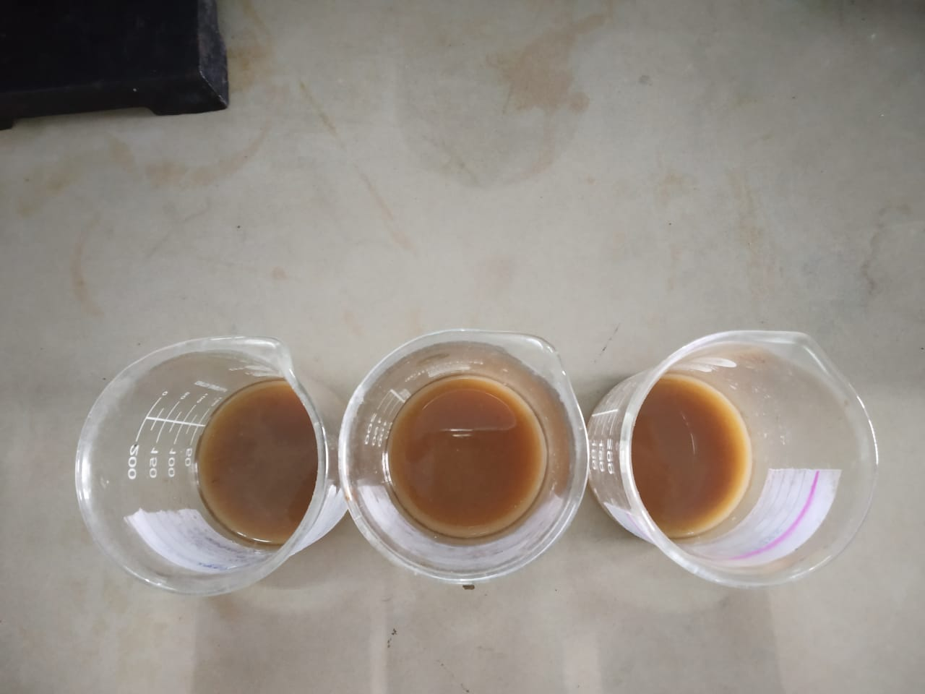 **Fig 4: shows the rate of fermentation in 7 days, 14 days, 21 days of C6H5COONa preservative in mousambi juice**

**OBSERVATION:-**

|  |  |  |  |  |  |  |  |  |  |  |
| --- | --- | --- | --- | --- | --- | --- | --- | --- | --- | --- |
| **EFFECT OF SUGAR ON COCONUT WATER (KHSO3)** | | | | | | | | | | |
| **Bottle no.** | **Wt. of sugar** | **Wt. of KHSO3** |  | **Day 1 to 3** | **Day 4** | **Day 5** | **Day 6** | **Day 7** | **Day 8** | **Day 9** |
| **I** | **5 gm** | **0.5 gm** | **color** | … | … | … | White blurry sol | White blurry sol | White blurry sol | White blurry sol |
| **I** | **5 gm** | **0.5 gm** | **odour** | … | unpleasant smell | unpleasant smell | unpleasant smell | Pungent smell | Unpleasant smell | Unpleasant smell |
| **I** | **5 gm** | **0.5 gm** | **fungus** | … | … | … | … | … | fungus | fungus |
| **II** | **10 gm** | **0.5 gm** | **color** | … | … | … | White blurry sol | White blurry sol | White blurry sol | White blurry sol |
| **II** | **10 gm** | **0.5 gm** | **odour** | … | unpleasant smell | unpleasant smell | Strong pungent smell | Strong pungent smell | Unpleasant smell | Unpleasant smell |
| **II** | **10 gm** | **0.5 gm** | **fungus** | … | … | … | … | … | fungus | fungus |
| **III** | **15 gm** | **0.5 gm** | **color** | … | … | … | White blurry sol | White blurry sol | White blurry sol | White blurry sol |
| **III** | **15 gm** | **0.5 gm** | **odour** | … | Unpleasant smell | Pungent smell | Strong pungent smell | Strong Unpleasant smell | Ethanolic smell | Unpleasant smell |
| **III** | **15 gm** | **0.5 gm** | **fungus** | … | … | … | … | … | fungus | fungus |

**OBSERVATION :-**

|  |  |  |  |  |  |  |  |  |  |  |
| --- | --- | --- | --- | --- | --- | --- | --- | --- | --- | --- |
| **EFFECT OF PRESERVATIVE KHSO3 ON COCONUT WATER** | | | | | | | | | | |
| **Bottle no.** | **Wt. of sugar** | **Wt. of KHSO3** |  | **Day 1 to 3** | **4** | **5** | **6** | **7** | **8** | **9** |
| **I** | **5gm** | **1 gm** | **Color** | … | Light yellow | Light yellow | Light yellow | Light yellow | Light yellow | Light yellow |
| **I** | **5 gm** | **1 gm** | **Odour** | … | Unpleasant smell | Unpleasant smell | Unpleasant smell | Strong pungent smell | Ethanolic smell | Strong ethanolic smell |
| **I** | **5 gm** | **1 gm** | **Fungus** | … | … | … | Few white fungus | White fungus | White and yellow fungus | Few white and yellow fungus |
| **II** | **5 gm** | **2 gm** | **Color** | … | Light yellow | Light yellow | Light yellow | Light yellow | Light yellow | Light yellow |
| **II** | **Gm** | **2 gm** | **Odour** | … | Unpleasant yellow | Unpleasant smell | Unpleasant smell | Strong pungent smell | Unpleasant smell | ethanolic smell |
| **II** | **5 gm** | **2 gm** | **Fungus** | … | … | … | … | Very few white fungus | White fungus | White fungus |
| **III** | **5 gm** | **3 gm** | **color** | … | Light yellow | Light yellow | Light yellow | Light yellow | Light yellow | Light yellow |
| **III** | **5 gm** | **3 gm** | **Odour** | … | … | … | Unpleasant smell | Unpleasant smell | Pungent smell | Unpleasant smell |
| **III** | **5 gm** | **3 gm** | **fungus** | … | … | … | … | … | Few white fungus | white fungus |

**OBSERVATION :-**

|  |  |  |  |
| --- | --- | --- | --- |
| **EFFECT OF TEMPERATURE ON COCONUT WATER** | | | |
| **Bottle no.** |  | **I** | **II** |
| **Temperature** |  | **0 degree** | **25 degree** |
| **Wt. of sugar** |  | **10 gm** | **10 gm** |
| **Wt. of KHSO3** |  | **1 gm** | **1 gm** |
| **Day 1** | **color** | White | White |
|  | **odour** | Fruity smell | Fruity smell |
|  | **fungus** | … | … |
| **Day 2** | **Color** | White | White |
|  | **Odour** | … | … |
|  | **fungus** | … | … |
| **Day 3** | **color** | … | … |
|  | **odour** | … | … |
|  | **fungus** | … | … |
| **Day 4** | **color** | … | … |
|  | **odour** | … | … |
|  | **Fungus** | … | … |
| **Day 5** | **Color** | … | … |
|  | **Odour** | … | … |
|  | **Fungus** | … | … |
| **Day 6** | **Color** | … | … |
|  | **Odour** | … | … |
|  | **Fungus** | … | … |
| **Day 7** | **Color** | … | Light yellow |
|  | **Odour** | Unpleasant | Unpleasant |
|  | **Fungus** | … | Few white fungus |
| **Day 8** | **Color** | … | Light yellow |
|  | **Odour** | unpleasant | pungent smell |
|  | **Fungus** | … | Few White and yellow fungus |
| **Day 9** | **Color** | … | Light yellow |
|  | **Odour** | Unpleasant smell | Unpleasant smell |
|  | **Fungus** | Few white fungus | White , yellow and black fungus |

**OBSERVATIONS :-**

|  |  |  |  |  |
| --- | --- | --- | --- | --- |
| **EFFECT OF TIME ON COCONUT WATER** | | | | |
| **Bottle no.** |  | **I** | **II** | **III** |
| **Wt. of KHSO3** |  | **1 gm** | **1 gm** | **1 gm** |
|  |  | **7 days** | **14 days** | **21 days** |
|  | **Color** | Light yellow | Light yellow | Light yellow |
|  | **Odour** | unpleasant smell | Unpleasant smell | Unpleasant smell |
|  | **Fungus** | Few white fungus | More white fungus | White ,yellow and black fungus |

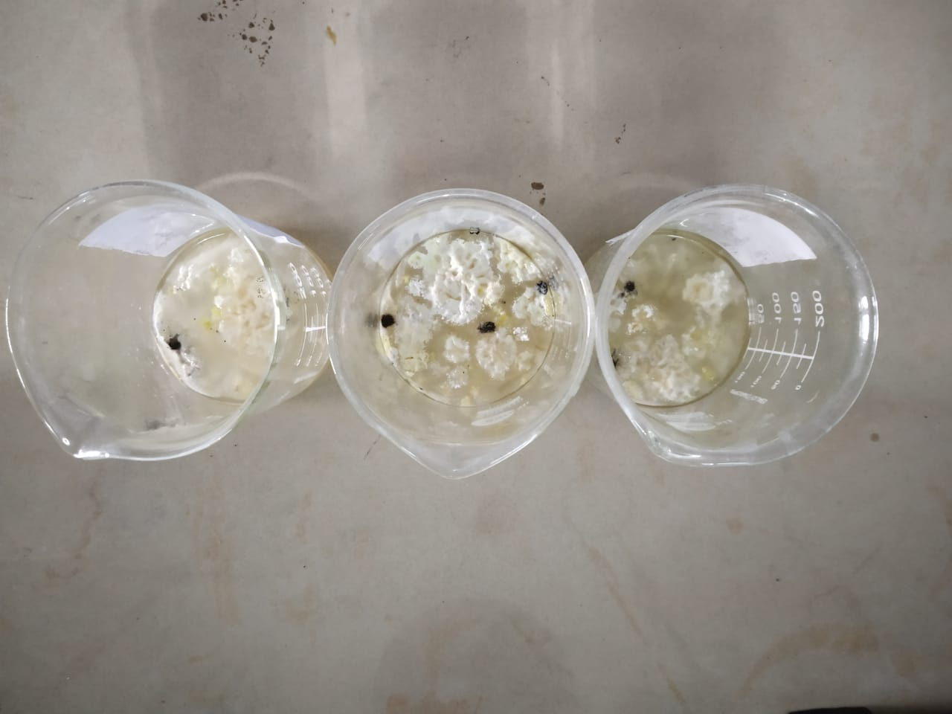 **Fig 5: shows rate of fermentation in 7 days, 14 days and 21 days of KHS03 preservative of coconut water**

**OBSERVATION :-**

|  |  |  |  |  |  |  |  |  |  |  |
| --- | --- | --- | --- | --- | --- | --- | --- | --- | --- | --- |
| **EFFECT OF SUGAR ON COCONUT WATER (C6H5COONa)** | | | | | | | | | | |
| **Bottle no.** | **Wt. of sugar** | **Wt. of C6H5COONa** |  | **Day 1 to 3** | **Day 4** | **Day 5** | **Day 6** | **Day 7** | **Day 8** | **Day 9** |
| **I** | **5 gm** | **0.5 gm** | **Color** | … | Light orange | Light orange | Light orange | Light orange | Dark orange | Dark orange |
| **I** | **5 gm** | **0.5 gm** | **Odour** | … | … | … | Pungent smell | Unpleasant smell | Unpleasant smell | unpleasant |
| **I** | **5 gm** | **0.5 gm** | **Fungus** | … | … | … | … | … | … | Fungus |
| **II** | **10 gm** | **0.5 gm** | **Color** | … | Light orange | Light orange | Light orange | Light orange | Dark orange | Dark orange |
| **II** | **10 gm** | **0.5 gm** | **Odour** | … | Pungent smell | Pungent smell | unpleasant | unpleasant | Unpleasant smell | unpleasant |
| **II** | **10 gm** | **0.5 gm** | **Fungus** | … | no | no | no | No | White fungus | White and yellow fungus |
| **III** | **15 gm** | **0.5 gm** | **color** | … | Light yellow | Light brown | Light brown | Light brown | Dark brown | Dark brown |
| **III** | **15 gm** | **0.5 gm** | **Odour** | … | Pleasant smell | Unpleasant smell | Unpleasant smell | ethanolic smell | Ethanolic smell | Ethanolic smell |
| **III** | **15 gm** | **0.5 gm** | **fungus** | … | no | no | no | Few fungus | fungus | White , yellow and black fungus |

**OBSERVATION :-**

|  |  |  |  |  |  |  |  |  |  |  |
| --- | --- | --- | --- | --- | --- | --- | --- | --- | --- | --- |
| **EFFECT OF PRESERVATIVE C6H5COONa ON COCONUT WATER** | | | | | | | | | | |
| **Bottle no.** | **Wt. of sugar** | **Wt. of C6H5C0ONa** |  | **Day 1 to 3** | **4** | **5** | **6** | **7** | **8** | **9** |
| **I** | **5gm** | **1 gm** | **Color** | … | Light yellow | Light yellow | Light yellow | Light yellow | Light orange | Light orange |
| **I** | **5 gm** | **1 gm** | **Odour** | … | … | … | … | … | Unpleasant smell | Unpleasant smell |
| **I** | **5 gm** | **1 gm** | **Fungus** | … | … | … | … | … | … | Few white fungus |
| **II** | **5 gm** | **2 gm** | **Color** | … | Light yellow | Light yellow | Light yellow | Light yellow | Light yellow | Yellowish orange |
| **II** | **Gm** | **2 gm** | **Odour** | … | … | … | … | … | Unpleasant smell | unpleasant smell |
| **II** | **5 gm** | **2 gm** | **Fungus** | no | no | No | No | no | no | No |
| **III** | **5 gm** | **3 gm** | **color** | … | Light yellow | Light yellow | Light yellow | Light yellow | Light yellow | Yellowish orange |
| **III** | **5 gm** | **3 gm** | **Odour** | … | … | … | … | … | … | Unpleasant smell |
| **III** | **5 gm** | **3 gm** | **fungus** | … | no | No | No | no | no | Few fungus |

**OBSERVATION :-**

|  |  |  |  |
| --- | --- | --- | --- |
| **EFFECT OF TEMPERATURE ON COCONUT WATER** | | | |
| **Bottle no.** |  | **I** | **II** |
| **Temperature** |  | **0 degree** | **25 degree** |
| **Wt. of sugar** |  | **10 gm** | **10 gm** |
| **Wt. of C6H5COONa** |  | **1 gm** | **1 gm** |
| **Day 1** | **color** | White | White |
|  | **Odour** | Fruity smell | Fruity smell |
|  | **fungus** | … | … |
| **Day 2** | **Color** | White | White |
|  | **Odour** | … | … |
|  | **fungus** | … | … |
| **Day 3** | **color** | … | Light orange |
|  | **odour** | … | Fruity smell |
|  | **fungus** | … | … |
| **Day 4** | **color** | … | Light orange |
|  | **odour** | … | … |
|  | **Fungus** | … | … |
| **Day 5** | **Color** | … | Light orange |
|  | **Odour** | … | … |
|  | **Fungus** | … | … |
| **Day 6** | **Color** | … | Light orange |
|  | **Odour** | … | … |
|  | **Fungus** | … | … |
| **Day 7** | **Color** | Light pink | Light orange |
|  | **Odour** | Unpleasant | … |
|  | **Fungus** | … | … |
| **Day 8** | **Color** | Light pink | orange |
|  | **Odour** | unpleasant | pungent smell |
|  | **Fungus** | … | Few White fungus |
| **Day 9** | **Color** | Light pink | Light orange |
|  | **Odour** | Unpleasant smell | Unpleasant smell |
|  | **Fungus** | … | White fungus |

**OBSERVATION :-**

|  |  |  |  |  |
| --- | --- | --- | --- | --- |
| **EFFECT OF TIME ON COCONUT WATER** | | | | |
| **Bottle no.** |  | **I** | **II** | **III** |
| **Wt. of C6H5COONa** |  | **1 gm** | **1 gm** | **1 gm** |
|  |  | **7 days** | **14 days** | **21 days** |
|  | **Color** | Light pink | Light pink | Light orange |
|  | **Odour** | unpleasant smell | unpleasant smell | Pungent smell |
|  | **Fungus** | Few white fungus | More white fungus | White and yellow fungus |

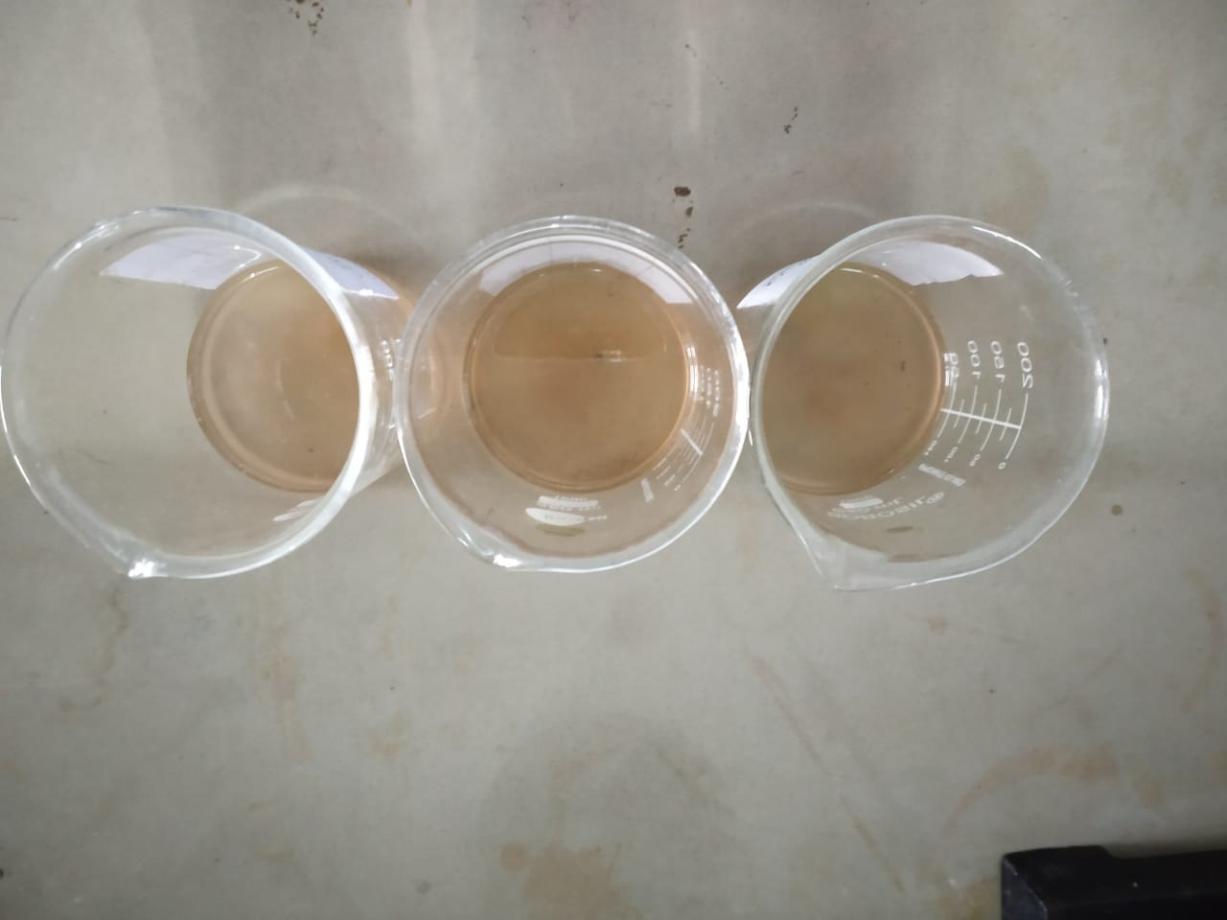 **Fig 6: shows rate of fermentation in 7 days,14 days and 21 days of C6H5COONa preservative**

**GRAPH:**

(1)EFFECT OF CONCENTRATION OF SUGAR

(For KHSO3)

No. of days🡪

Rate of fermentation🡪

(For C6H5COONa)

No. of days🡪

Rate of fermentation🡪

🡪X-axis represents beaker having 80g/40ml/40ml of mango jam/mosambi juice/cocnut water, 0.5g of preservative and 5g, 10g, 15g of sugar in beaker 1, 2, 3.

🡪Y-axis represents the number of days in which mango jam/mosambi juice/ coconut water start fermented.

(2)EFFECT OF CONCENTRATION OF PRESERVATIVE

(FOR KHSO3)

No. of days🡪

Rate of fermentation🡪

(FOR C6H5COONa)

No. of days🡪

Rate of fermentation🡪

🡪X-axis represents beakers having 80g/40ml/40ml of mango jam/mosambi juice/coconut water, 5g of sugar and 1g, 2g, 3g of preservatives in beaker 1,2,3.

🡪Y-axis represents the number of days in which mango jam/mosambi juice/coconut water start fermented.

(3)EFFECT OF TEMPERATURE

(FOR KHSO3)

No. of days🡪

Rate of fermentation🡪

(FOR C6H5COONa)

No. of days🡪

Rate of fermentation🡪

🡪X-axis represents beakers having 80g/40ml/40ml of mango jam/mosambi juice/coconut water, 1g of preservative and 10g of sugar.

🡪Y-axis represents the number of days in which mango jam/mosambi juice/coconut water start fermented.

(4)EFFECT OF TIME

(FOR KHSO3)

No. of days🡪

Rate of fermentation🡪

(FOR C6H5COONa)

No. of days🡪

Rate of fermentation🡪

🡪X-axis represents beakers having 80g/40ml/40ml of mango jam/mosambi juice/coconut water containing 1g of preservative.

🡪Y-axis represents the number of days in which mango jam/mosambi juice/coconut water start fermented.

**RESULT AND DISCUSSION**

**(1)FOR MANGO JAM:**

(a)EFFECT OF CONCENTRATION OF SUGAR:

Above observation data shows that with increase in concentration of sugar causes deterioration of fruit jam due to growth of fungus.

After comparing the graph of concentration of sugar we can say that C6H5COONa is better than KHSO3 for the preservation of mango jam.

(b) EFFECT OF CONCENTRATION OF PRESERVATIVE:

Above observation data shows that with increase in concentration of preservatives, increase more time of preservation.

After comparing the graph of effect of concentration of preservative we can say that C6H5COONa preserves better than KHSO3.

(C) EFFECT OF TEMPERATURE:

Above observation data shows that with increase in temperature causes fast fermentation of jam.

After comparing the graph of effect of temperature we can say that C6H5COONa preserves better than KHSO3.

(d) EFFECT OF TIME:

Above observation data shows that with increase of days the quality of the jam deteriorates.

After comparing the graph of effect of time we can say that C6H5COONa preserves better than KHSO3.

**(2)FOR MOSAMBI JUICE**

(a) EFFECT OF CONCENTRATION OF SUGAR:

Above observation data shows that with increase in concentration of sugar causes deterioration of mosambi juice due to growth of fungus.

After comparing the graph of effect of concentration of sugar we can say that C6H5COONa preserves better than KHSO3.

(b) EFFECT OF CONCENTRATION OF PRESERVATIVE:

Above observation data shows that with increase in concentration of preservative, increases more time of preservation.

After comparing the graph of effect of concentration of preservative it shows that KHSO3 preserves better than C6H5COONa.

(c) EFFECT OF TEMPERATURE:

Above observation data shows that with increase of temperature causes fast fermentation of mosambi juice.

After comparing the graph of effect of temperature we say that KHSO3 preserves better than C6H5COONa.

(d) EFFECT OF TIME:

Above observation data shows that with increase of days the quality of mosambi juice deteriorates.

After comparing the graph of effect of time we can say that C6H5COONa preserves better than KHSO3.

**(3)FOR COCONUT WATER**

(a) EFFECT OF CONCENTRATION OF SUGAR:

Above observation data shows that with increase in concentration of sugar causes deterioration of coconut water.

After comparing the graph we can say that C6H5COONa preserves better than KHSO3.

(b) EFFECT OF CONCENTRATION OF PRESERVATIVE:

Above observation data shows that with increase in concentration of preservative increases more time of preservation.

After comparing the graph it shows that C6H5COONa preserves better than KHSO3.

(c) EFFECT OF TEMPERATURE:

Above observation data shows that with increase in temperature causes fast fermentation of coconut water.

After comparing the graph it shows that KHSO3 preserves better than C6H5COONa.

(d) EFFECT OF TIME:

Above observation data shows that with increase of days the quality of coconut water deteriorates.

After comparing the graph we can say that C6H5COONa preserves better than KHSO3.

**CONCLUSION**

From this research we get different ideas about two preservatives-(sodium benzoate and potassium bisulphite). From this report we conclude that sodium benzoate is very good preservative than potassium bisulphite in the case of preservation. Sodium benzoate has more time of preservation than potassium bisulphite. Sodium benzoate is primarily added to acidic foods. It increases the acidity of food, which also increases the intensity of flavor.

But if there is a matter of health, we can say that potassium bisulphite is a good preservative than sodium benzoate, because sodium benzoate has ability to convert into benzene, a known carcinogen which is very harmful for human body .It increases the risk of inflammation, oxidative stress, obesity, ADHD and allergies. So, its use is limited by the FDA in the U.S to 0.1% by weight so that there is a little chance of formation of benzene.

Potassium bisulphite widely used in the preservation of colorless food items. It is also known as color enhancer, because it has a bleaching agent which may change the color of food.

**REFERENCE:**

* Food additives data book, Second edition by Jim Smith.

<http://doi.org/10.1002/9781444397741.ch11>

* Food preservatives by Nicholas J Russell, Grahame W.GOULD.
* NCERT book of class 12 chemistry.
* <http://www.thetrustedtrolley.com.au>.
* <http://www.livestrong.com/article/308673-potassium-bisulphite-asa-food>- preservative.